Acceptance tests
Acme-Poll 2.0
Development team
Identifier | FINALFANTASY
Members | SANCHEZ REYES, ADRIAN  BOZADA MARQUEZ, JESUS ENRIQUE  GIRALDO RUIZ, JOSE  LOPEZ MUÑOZ, JUAN CARLOS  DANS CABALLERO, MARIA REMEDIOS  CAMPOS ROMERO, MIGUEL
Testing team
Identifier | ReiCarMacLuqQuiMin
Members | CARRASCOSA OLIVA, SERGIO  REINA LOPEZ, PABLO  LUQUE MENDOZA, JOSÉ MANUEL  VALERA QUIANO, SILVIA  MINGUEZ LEÓN, ANTONIO JESÚS  MACÍAS LÓPEZ, PABLO
Indexing data
Test designers | GIRALDO RUIZ, JOSÉ  DANS CABALLERO, MARÍA REMEDIOS
Testers | LUQUE MENDOZA, JOSÉ MANUEL  VALERA QUIANO, SILVIA
Notes

Table of contents
LEVEL C 3
Use case 001 List his or her bills 3
Use case 002 Add a receipt to a bill that is unpaid. Adding the receipt requires double confirma-tion, since it cannot be changed later 4
Use case 003 Create a bill for a poll. The amount to be paid is determined by administrators build-ing on a variety of factors that are not easy to formalise, but are correlated to the number of instances. Typically, the amount ranges from a minimum of €1.00 up to €100.00 in cases in which a poll has millions of instances 5
Use case 004 List the bills that have to be endorsed 6
Use case 005 List the bills that have been endorsed 7
Use case 006 Endorse a bill for which the corresponding poller has added a receipt 8
Use case 007 Display a dashboard with the following information 9
LEVEL B 10
Use case 008 Exchange messages with other actors of the system 10
Use case 009 Manage his or her message folders, which includes creating, listing, modifying, and deleting them 10
Use case 010 Manage his or her messages, which includes writing and sending them, deleting them, moving them from one folder to another one, and the like 12
LEVEL A 13
Use case 011 Retrieve his or her instance of the poll later by entering the corresponding ticker. He or she must be allowed to modify it as long as the poll is active 13
Additional tests 14

LEVEL C

Use case 001 List his or her bills

Description
An actor must be able to access list his or her bills

Access
Any authenticated actor can access this use case. Please, use the following credentials:
User: poller2
Password: poller2
User: admin
Password: admin
Tests
Test 1
Description | List his or her bills
Expected | Once logged in, 'Bills' tab will lead to the list view. It must work in both languages
Outcome | Ok. se muestra correctamente:  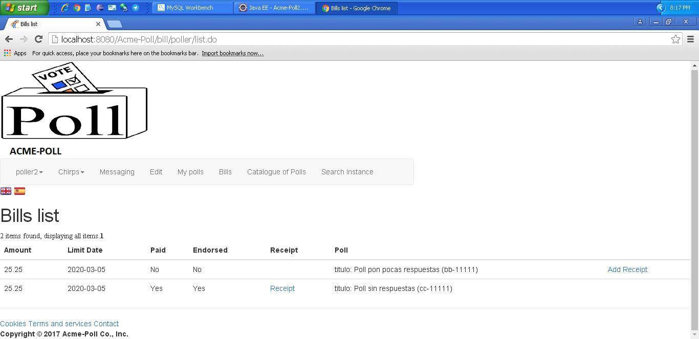
Notes

Use case 002 Add a receipt to a bill that is unpaid. Adding the receipt requires double confirma-tion, since it cannot be changed later

Description
An actor must be able to access add a receipt to a bill that is unpaid. Adding the receipt requires double confirma-tion, since it cannot be changed later
Access
Any authenticated actor can access this use case. Please, use the following credentials:
User: poller2
Password: poller2
Tests
Test 1
Description | Add a receipt to a bill that is unpaid. Adding the receipt requires double confirma-tion, since it cannot be changed later
Expected | A actor can add a receipt to a bill that is unpaid.
Outcome | Se añade correctamente.  Paso 1 (Botón bills):  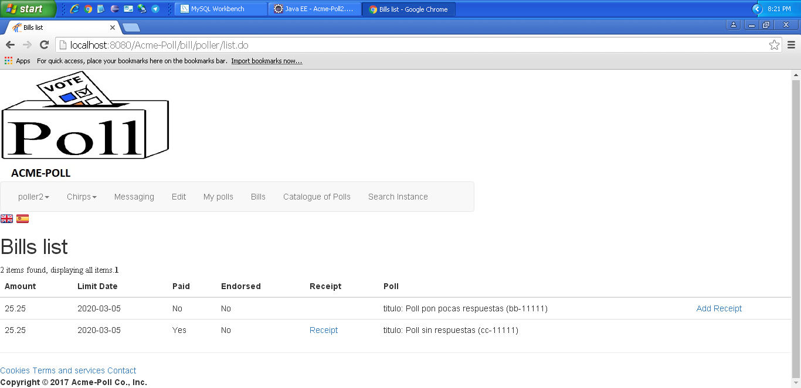  Paso 2 (Add receipt):  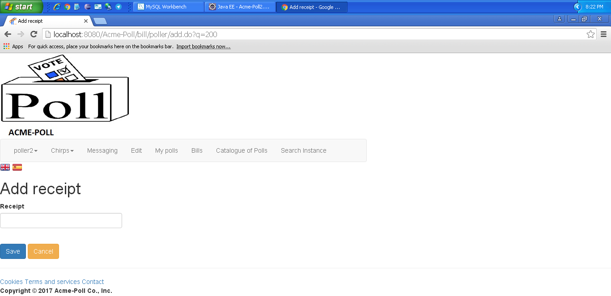
Notes

Use case 003 Create a bill for a poll. The amount to be paid is determined by administrators build-ing on a variety of factors that are not easy to formalise, but are correlated to the number of instances. Typically, the amount ranges from a minimum of €1.00 up to €100.00 in cases in which a poll has millions of instances

Description
An admin must be able to access create a bill for a poll. The amount to be paid is determined by administrators build-ing on a variety of factors that are not easy to formalise, but are correlated to the number of instances. Typically, the amount ranges from a minimum of €1.00 up to €100.00 in cases in which a poll has millions of instances
Access
Any authenticated actor can access this use case. Please, use the following credentials:
User: admin
Password: admin
Tests
Test #
Description | Create a bill for a poll. The amount to be paid is determined by administrators build-ing on a variety of factors that are not easy to formalise, but are correlated to the number of instances. Typically, the amount ranges from a minimum of €1.00 up to €100.00 in cases in which a poll has millions of instances
Expected | Once logged in, 'Catalogue of polls - Create bill' tab will lead to the create view. It must work in both languages
Outcome
Notes

Use case 004 List the bills that have to be endorsed

Description
An admin must be able to access list the bills that have to be endorsed
Access
Any authenticated actor can access this use case. Please, use the following credentials:
User: admin
Password: admin
Tests
Test 1
Description | List the bills that have to be endorsed
Expected | Once logged in, 'Bills paid' tab will lead to the create view. It must work in both languages
Outcome | Se muestra correctamente:  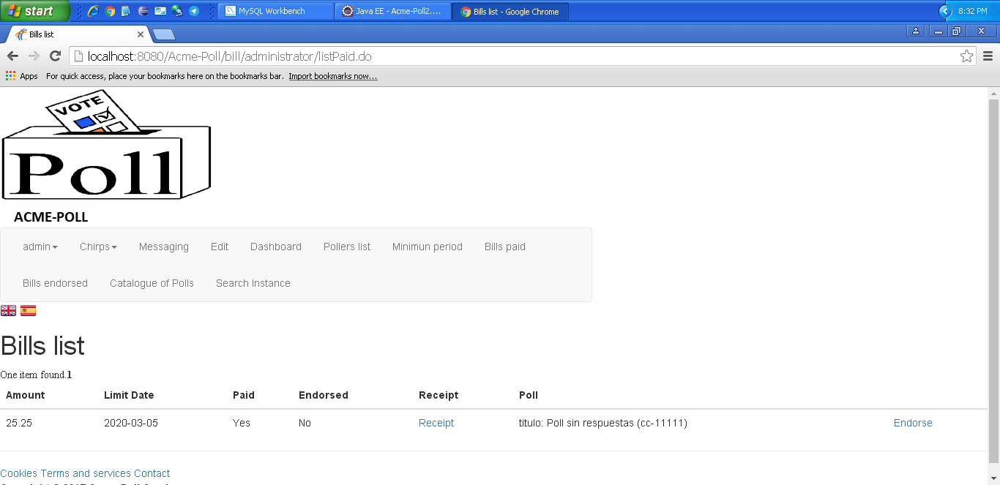
Notes

Use case 005 List the bills that have been endorsed

Description
An actor must be able to access list the bills that have been endorsed
Access
Any authenticated actor can access this use case. Please, use the following credentials:
User: admin
Password: admin
Tests
Test 1
Description | List the bills that have been endorsed
Expected | Once logged in, 'Bills endorsed' tab will lead to the create view. It must work in both languages.
Outcome | Se muestra correctamente:  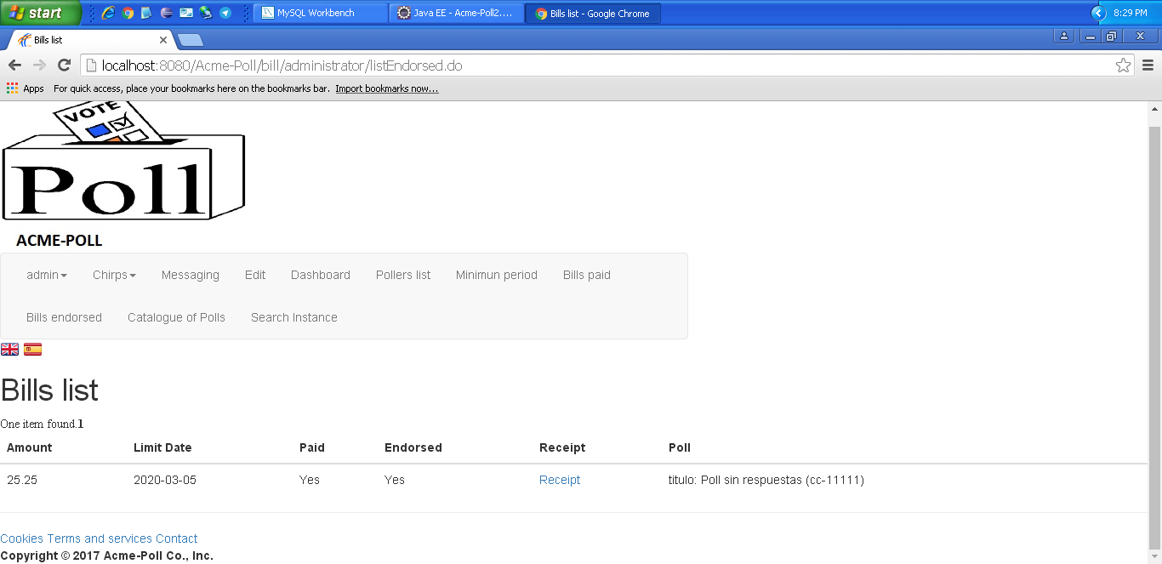
Notes

Use case 006 Endorse a bill for which the corresponding poller has added a receipt

Description
An admin must be able to access Endorse a bill for which the corresponding poller has added a receipt

Access
Any authenticated actor can access this use case. Please, use the following credentials:
User: admin
Password: admin

Tests
Test 1
Description | Endorse a bill for which the corresponding poller has added a receipt
Expected | Desde la lista de facturas pendientes de aprobar o facturas pagadas, aprobamos una factura que nos debe aparecer en la lista de facturas aprobadas.
Outcome | Lista de bill paids antes de aprobar la factura:  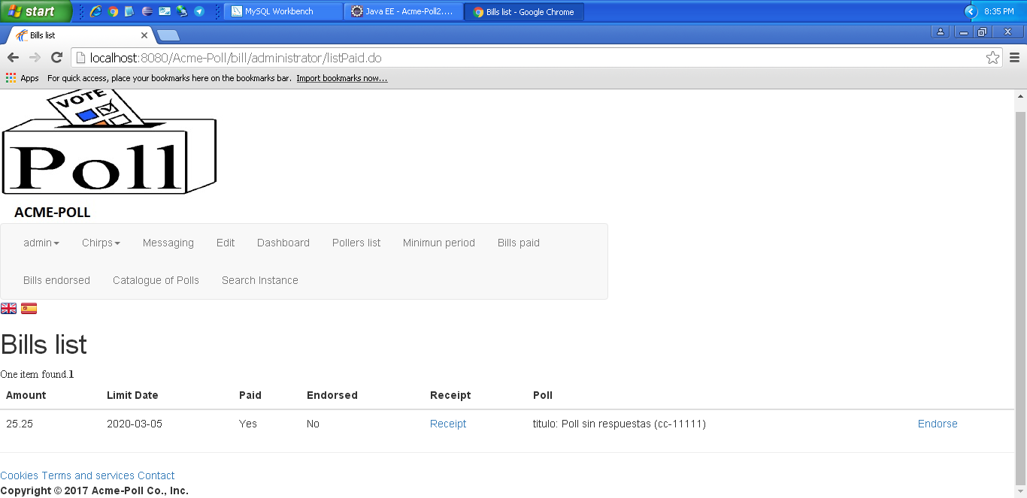  Lista de bill endorseds después de aceptar esta factura:  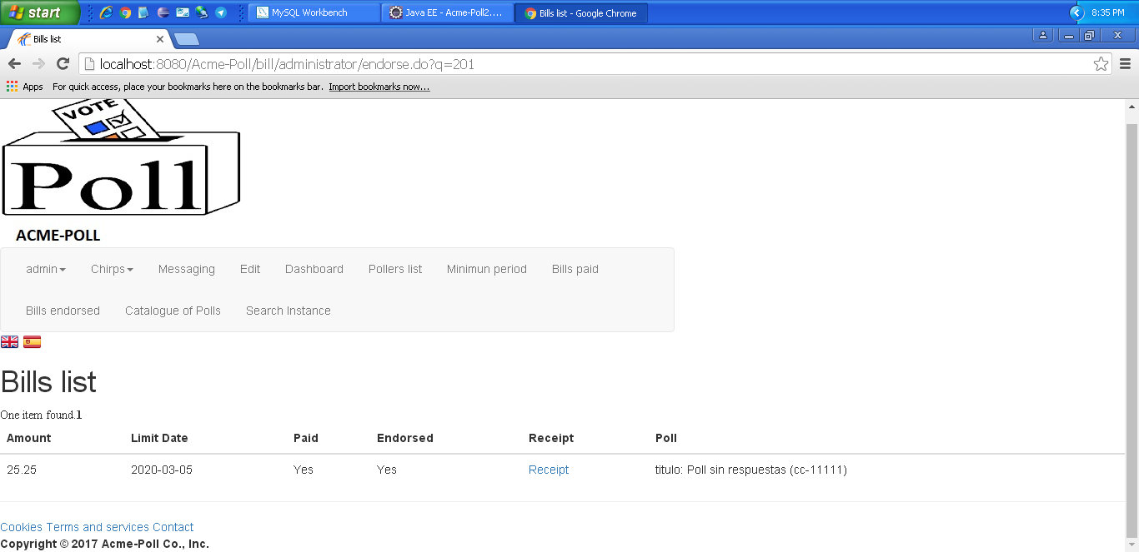
Notes

Use case 007 Display a dashboard with the following information

Description
An admin must be able to access display a dashboard with the following information

Access
Any authenticated actor can access this use case. Please, use the following credentials:
User: admin
Password: admin

Tests
Test 1
Description | Display a dashboard with the following information
Expected | Once logged in, 'Dashboard' tab will lead to the list view. It must work in both languages.
Outcome | Despliega dashboard correctamente:  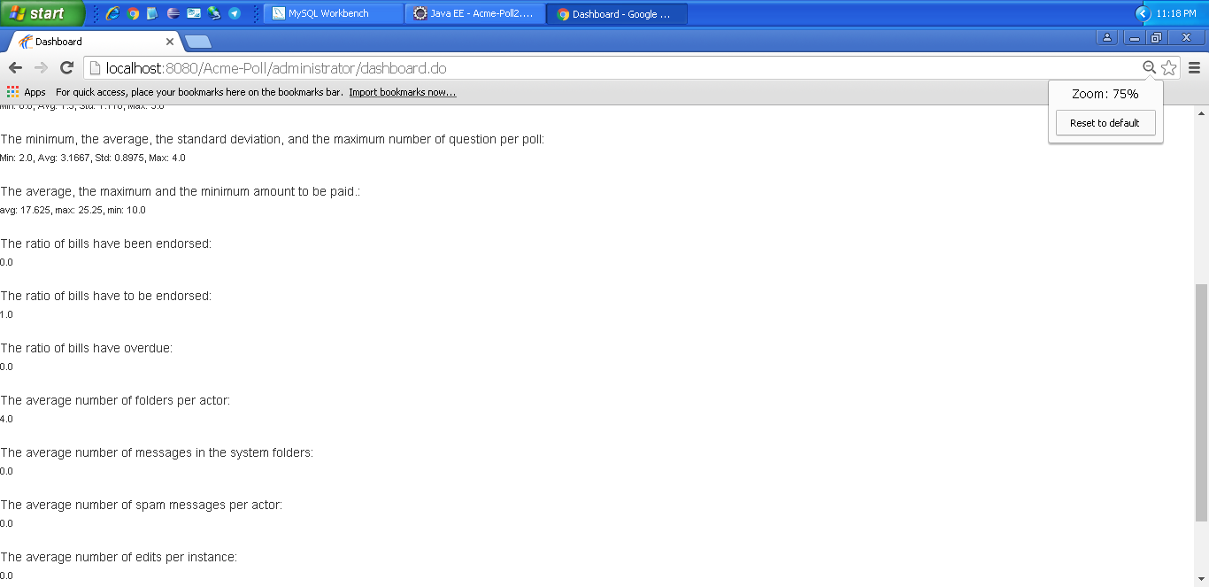
Notes

LEVEL B

Use case 008 Exchange messages with other actors of the system

Description
An actor must be able to access exchange messages with other actors of the system
Access
Any authenticated actor can access this use case. Please, use the following credentials:
User: poller1
Password: poller1
User: admin
Password: admin

Tests
Test 1
Description | Exchange messages with other actors of the system
Expected | Once logged in, 'Messaging - new message' tab will lead to the create view. It must work in both languages.
Outcome | Todo correcto. Se muestra el formulario para enviar mensajes:  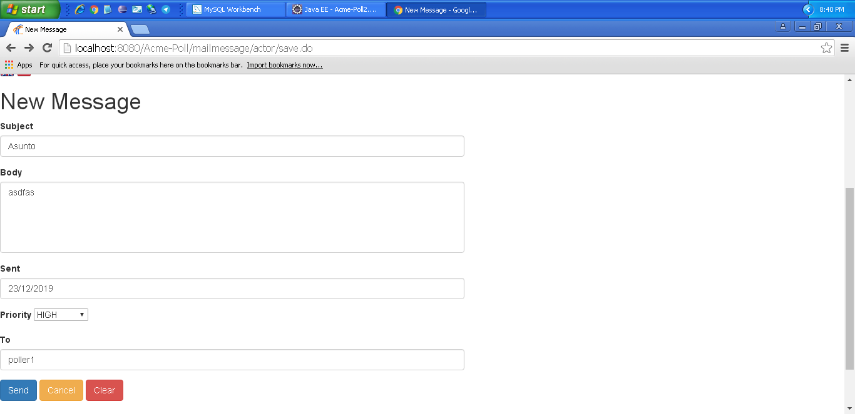  El mensaje se crea en la carpeta outbox:  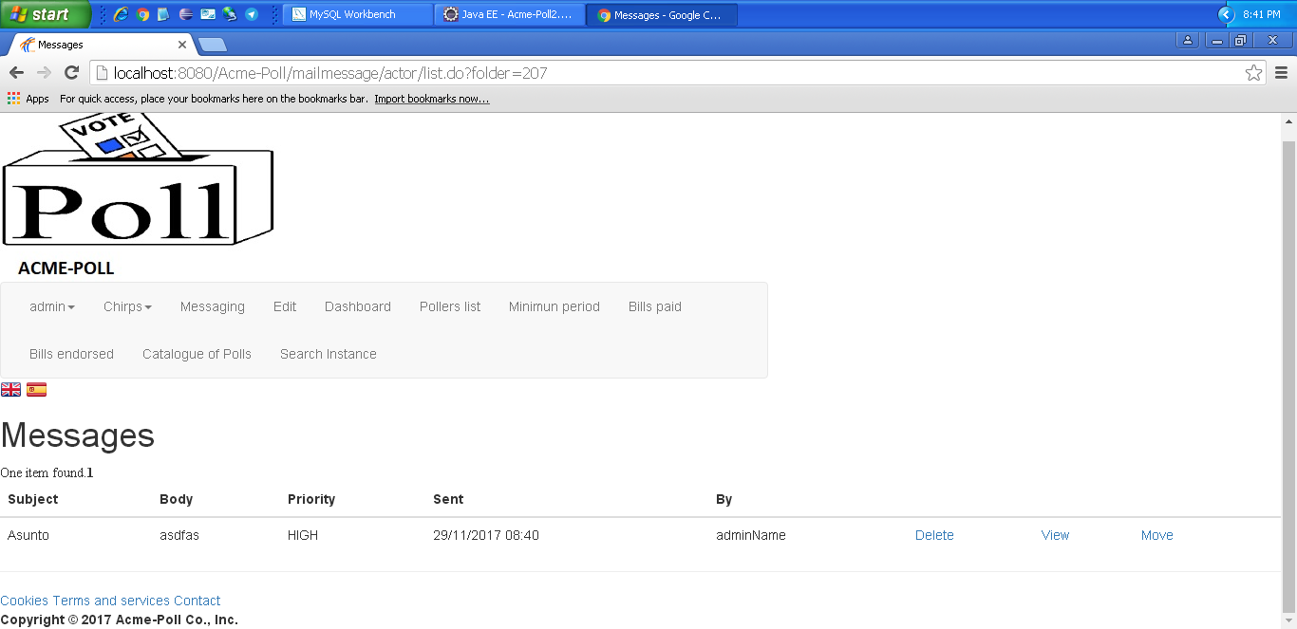  El mensaje aparece en la carpeta inbox del poller1:
Notes

Test 2
Description | Exchange messages with other actors of the system
Expected | Intentamos dejar el campo subject vacío.
Outcome | Error. Podemos enviar un mensaje sin sujeto.
Notes

Test 3
Description | Exchange messages with other actors of the system
Expected | Intentamos dejar el campo destino vacío.
Outcome | Error. Podemos crear un mensaje sin destino, que no se envía pero se mete en la carpeta outbox.
Notes

Use case 009 Manage his or her message folders, which includes creating, listing, modifying, and deleting them

Description
An actor must be able to access manage his or her message folders, which includes creating, listing, modifying, and deleting them
Access
Any authenticated actor can access this use case. Please, use the following credentials:
User: poller1
Password: poller1
User: admin
Password: admin
Tests
Test 1
Description | List folder
Expected | Once logged in, 'Messaging' tab will lead to the list view. It must work in both languages.
Outcome | Ok. Las carpetas se muestran correctamente:  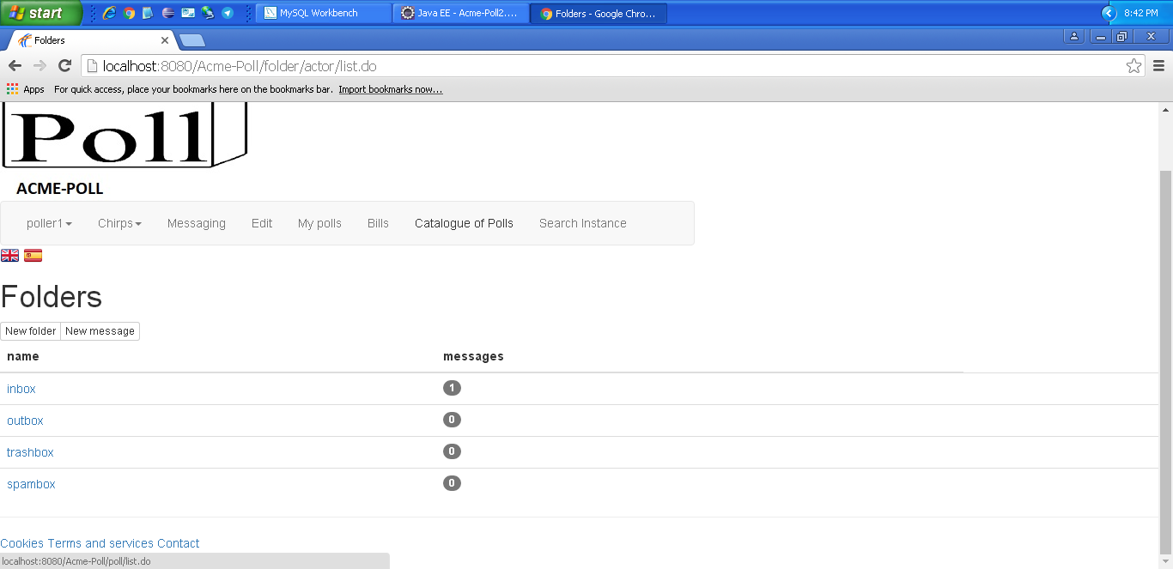
Notes

Test 2
Description | Create folder
Expected | Once logged in, 'Messaging - new folder' tab will lead to the create view. It must work in both languages.
Outcome | Formulario para crear una carpeta:  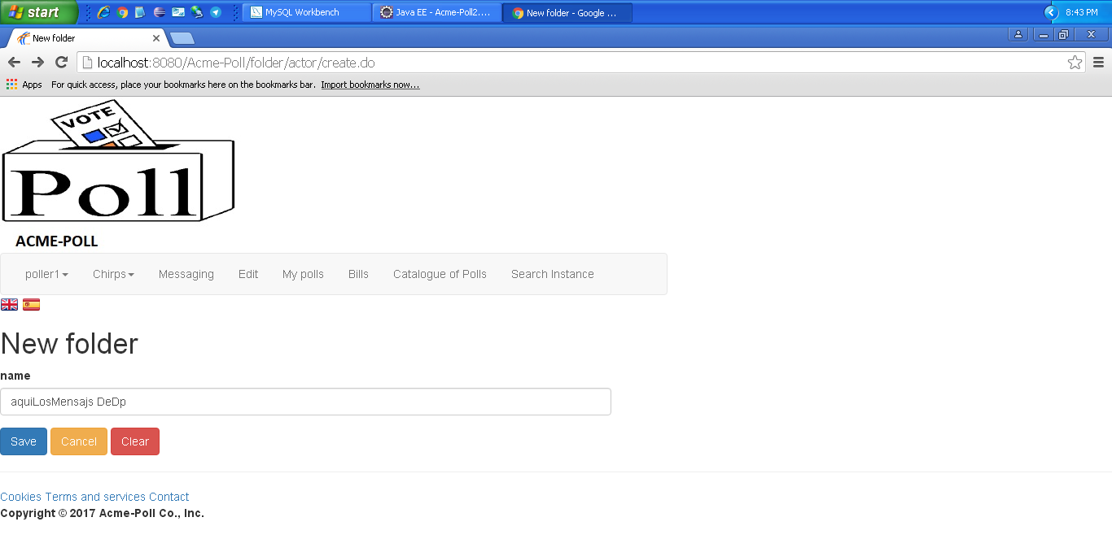  Carpeta creada:  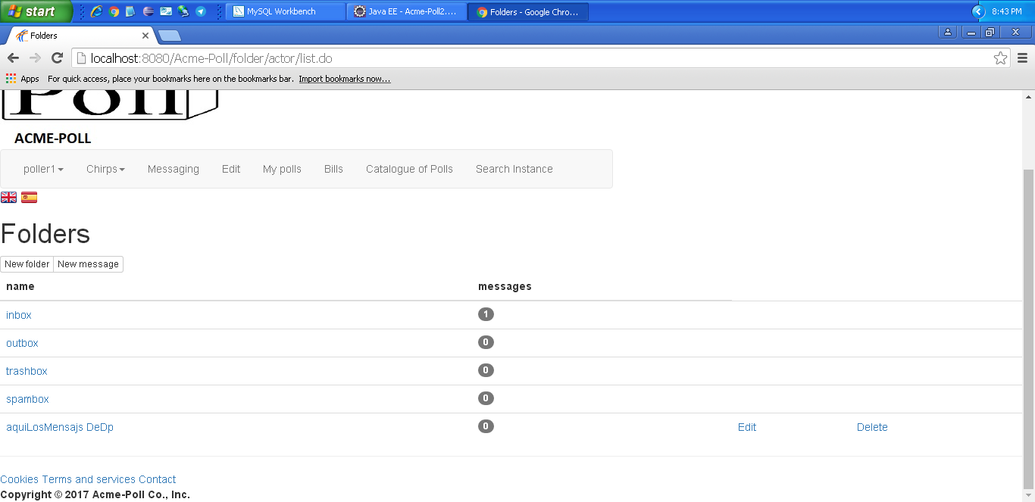
Notes

Test 3
Description | Create folder
Expected | Once logged in, 'Messaging - new folder' tab will lead to the create view. It must work in both languages. Intentamos crear una carpeta con un nombre en blanco. Nos muestra un mensaje de error.
Outcome | Error. Nos deja crear la carpeta con un nombre vacío.
Notes

Test 4
Description | Edit folder
Expected | Once logged in, 'Messaging - edit' tab will lead to the edit view. It must work in both languages.
Outcome | Funciona correctamente, formulario de editar:  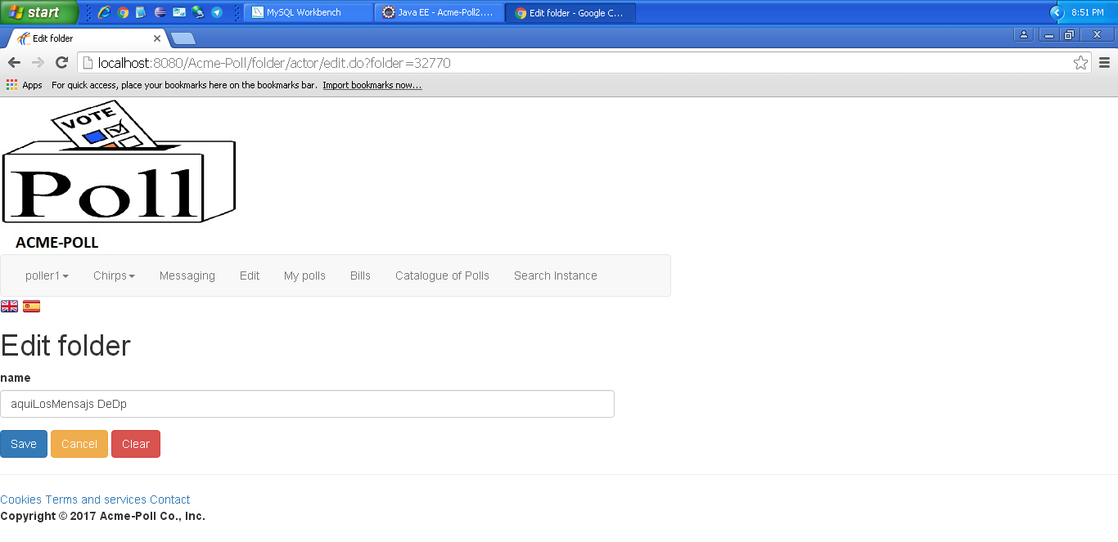  Carpeta editada:  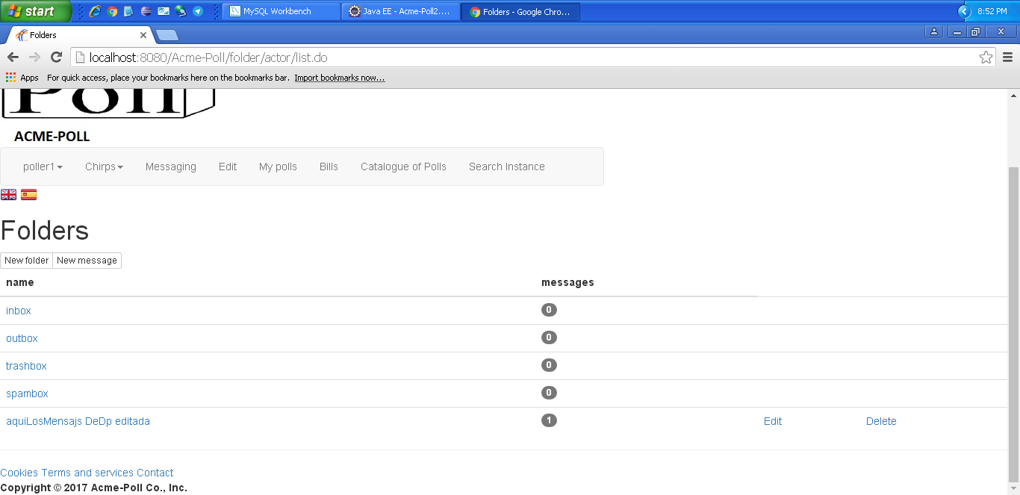
Notes

Test 5
Description | Delete folder
Expected | Once logged in, 'Messaging - delete'. It must work in both languages.
Outcome | Funciona correctamente.  Antes de borrar:  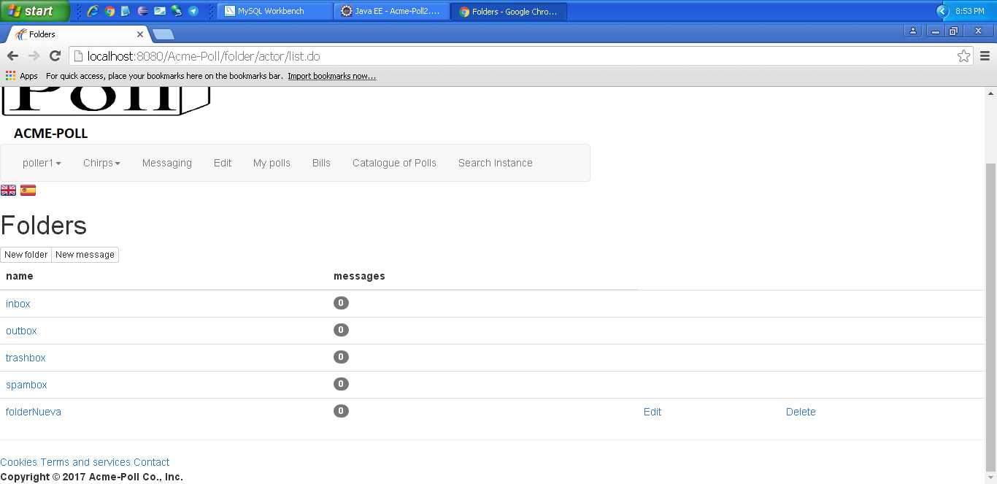  Después:  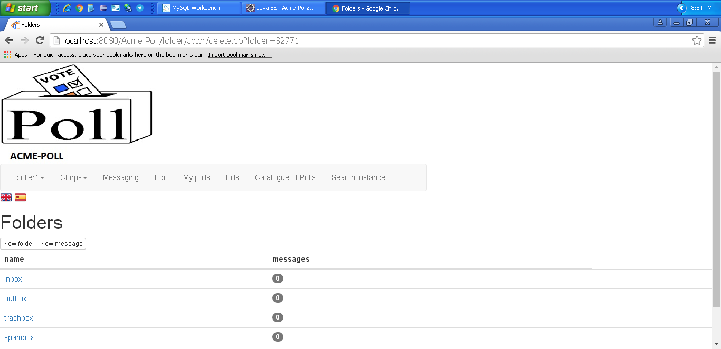
Notes

Use case 010 Manage his or her messages, which includes writing and sending them, deleting them, moving them from one folder to another one, and the like

Description
An actor must be able to access manage his or her messages, which includes writing and sending them, deleting them, moving them from one folder to another one, and the like
Access
Any authenticated actor can access this use case. Please, use the following credentials:
User: poller1
Password: poller1
User: admin
Password: admin
Tests
Test 1
Description | View message
Expected | Once logged in, 'Messaging - click folder - view' tab will lead to the view. It must work in both languages.
Outcome | Se puede ver correctamente un mensaje:  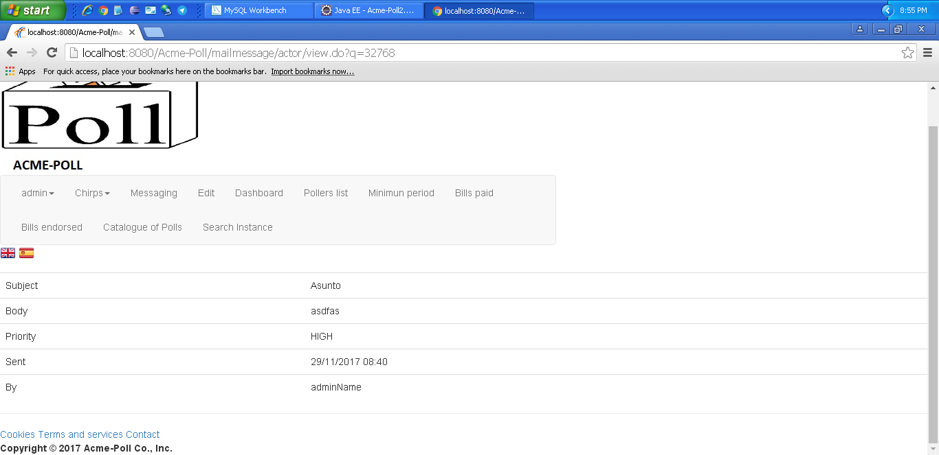
Notes

Test 2
Description | Delete message
Expected | Once logged in, 'Messaging - click folder - delete' tab will lead to the view. It must work in both languages.
Outcome | Mueve correctamente el mensaje a la carpeta trashbox.
Notes

Test 3
Description | Move message
Expected | Once logged in, 'Messaging - click folder - move' tab will lead to the move view. It must work in both languages.
Outcome | Mueve correctamente un mensaje:  Mensajes antes de mover nada:  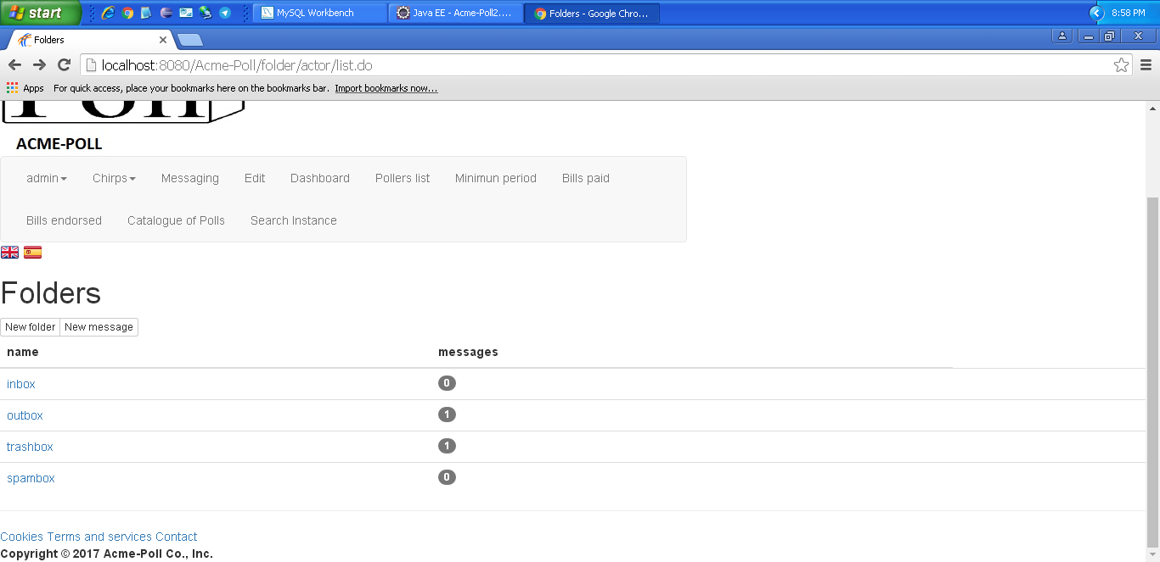  Movemos de outbox a spambox:  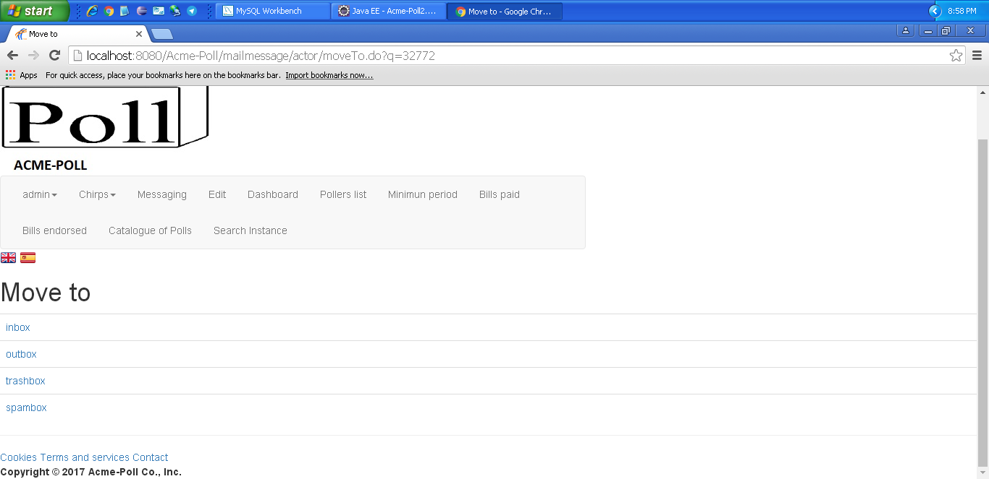  Después:  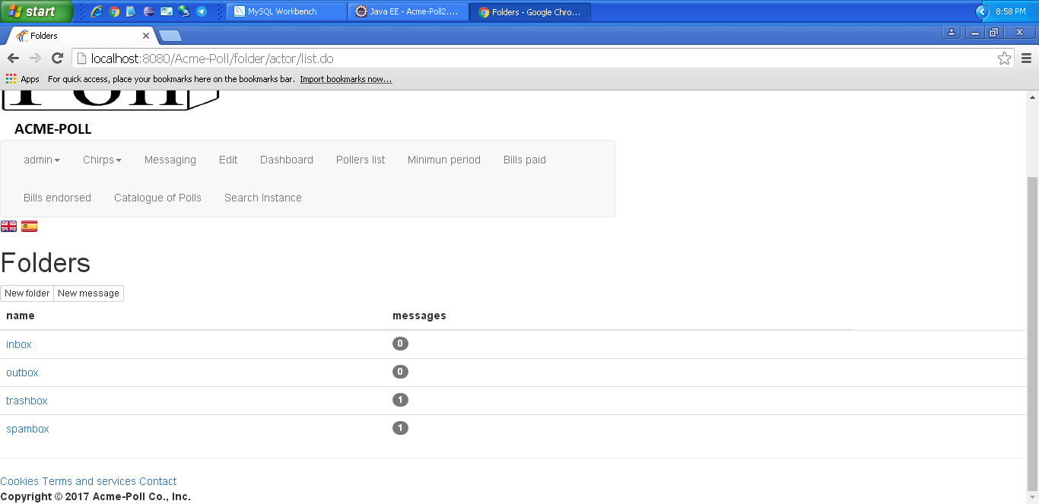
Notes

LEVEL A

Use case 011 Retrieve his or her instance of the poll later by entering the corresponding ticker. He or she must be allowed to modify it as long as the poll is active

Description
Everyone retrieve his or her instance of the poll later by entering the corresponding ticker. He or she must be allowed to modify it as long as the poll is active
Access
Everyone can access this use case
Tests
Test 1
Description | Retrieve his or her instance of the poll later by entering the corresponding ticker. He or she must be allowed to modify it as long as the poll is active
Expected | Once in the master page, the 'Search instance'. tab will lead to the edit view. It must work in both languages.
Outcome
Notes

Additional tests
If necessary, design additional tests that cannot be easily associated with a particular use case. Describe them in this section.
Test #999
Description | Describe the test that must be performed.
Expected | Describe what you expect from this test. Include screenshots if necessary.
Outcome | Describe what you’ve got when you performed this test. Add screenshots if necessary. Please, make sure that your description is enough for a developer to repeat what you’ve done, so that he or she can correct the problem.
Notes | Add notes if necessary.

